**Religious Tolerance and the Implementation of Climate Change Policies: Analysis from the Perspective of Institutional Logic**

Lya Paola Sierra1, Felipe Serrano2, Sergio A. Barona3

1Corresponding author. Faculty of Economic and Administrative Sciences, Pontificia Universidad Javeriana, Cali, Colombia, 760031. Email: [lyap@javerianacali.edu.co](mailto:lyap@javerianacali.edu.co). ORCID: 0000-0002-8909-8977

2 Faculty of Economic and Administrative Sciences, Pontificia Universidad Javeriana, Cali, Colombia, 760031. Email: [felipe1214@javerianacali.edu.co](mailto:felipe1214@javerianacali.edu.co).

3 Faculty of Economic and Administrative Sciences, Pontificia Universidad Javeriana, Cali, Colombia, 760031. Email: [sergio.barona@javerianacali.edu.co](mailto:sergio.barona@javerianacali.edu.co). ORCID: 0000-0001-8390-6673.

**Highlights**

* We construct a cross-country index of religious tolerance.
* We study the link between this index and a climate change policy stringency index.
* Religious tolerance correlates with a country’s ability to adopt stricter climate change policies.
* We show that some aspects of religion can promote climate-change-focused policies.

**Abstract**

Religion, as an important dimension of culture, has been identified as having an impact on the effective implementation of strategies to halt climate change. However, there is no consensus on the direction of this effect. In this paper, we evaluate the impact of religion on the implementation of policies against climate change, focusing on religious tolerance as an internal logic of religion. For this purpose, we construct a religious tolerance index using data from the World Value Survey and, thereafter, we estimated an econometric model that evaluates its impact on the Climate Change Policy Stringency (CCPS) index, built by Sharma et al. (2021). Unlike other studies, our findings support the idea that there are aspects of religion, such as religious tolerance, that can contribute to a more effective implementation of climate-change-focused policies. Moreover, the evidence indicates that the higher a country's level of religious tolerance, the greater its capacity to adopt more stringent climate change policies.

**Keywords**

Climate change · Climate policy · Religion · Religious tolerance · Religion institutions

**JEL**

O13 · Q56 · Q58 · Z12

1. **Introduction**

Climate change and the environmental crisis resulting from its effects are indisputable realities. Despite the fact that there are still voices that refuse to accept this situation, scientific evidence points to the unquestionable and imperative need to take decisive action to mitigate its possible and increasingly imminent and devastating effects (IPCC, 2022). Among the various research objectives aimed at overcoming the climate crisis, we find the analysis of the variables that favour the implementation of policies dedicated to halting climate change. These objectives are fully in consonance with the proposal of the United Nations (2018) in Sustainable Development Goals seven and thirteen, and in order that they may be addressed taking into account their complexity, culture must be considered as a central element, since it plays a decisive role in human decisions (Weber, 1930). Henceforth, this study will explore religion as an important dimension of culture, and its conceivable impact on the implementation of policies against climate change.

In this sense, by focusing on the cultural dimension, we maintain that the new institutional theory attaches considerable importance to cultural elements since it regards the study of institutions as necessary to understand the behaviour of organizations (Meyer & Rowan, 1977; DiMaggio, & Powell, 1983). From the standpoint of institutional theory, we find Hoffman's (2011) research, which proposes that there are two institutional logics (convinced and sceptical) in opposition with each other on the issue of climate change; moreover, he points out that the confrontation between these logics seems to lead to what he calls a "logical schism". He goes on to maintain that in this context the social sciences have the responsibility to provide elements that could help overcome this confrontation, with arguments based on negotiation frameworks such as religion. However, from a different point of view, Sharma et al. (2021) reveal a negative impact of religion on the implementation of policies against climate change, suggesting it to be a barrier, while at the same time, the higher the level of religiosity that exists in a country, the greater the difficulty there will be in the application of such policies.

In short, while from one viewpoint, religion seems to be put forward as a tool that offers ways to resolve a conflict in the area of climate change, from another, it is considered as an obstacle that prevents the application of measures to deal with the environmental crisis. With the idea of contributing to research aimed at offering methods of halting the climate crisis, this research leans towards offering literature providing a more complete understanding of the influence of religion on the application of public policies on the part of countries, in the face of climate change.

Our interest will be centred around religious tolerance (as an internal logic of religion) and its impact on the implementation of policies against climate change, a relationship that has not previously been addressed. By constructing a religious tolerance index, we will show that a dimension of religion can contribute to the implementation of climate change policies. This index of religious tolerance is created from the database The World Values Survey (WVS) (Haerpfer, et al., 2022), and thereafter we estimate a model that evaluates its impact on the climate change policy stringency (CCPS) index, built by Sharma et al. (2021). If religious tolerance is positively related to the implementation of climate change policies, we will be able to explain why we have found climate change-focused projects driven by religion.

The remainder of this paper is organized as follows: in Section 2, we will review the literature that highlights the need to address the various logics present in religion, including religious tolerance and its relationship with climate change. Section 3 introduces the data used and the procedures to measure both religious tolerance and climate change policy stringency. In Section 4, we will describe the adopted model, followed by the results of the proposed model and, subsequently, a presentation of the robustness tests applied to the model. In the last section, some conclusions are drawn, and future research directions are proposed.

1. **Related work**
2. **Religion and climate change**

Prior research linking religiosity and climate change has dissimilar results in terms of the impact that religiosity has had on the implementation of strategies to halt climate change. For instance, Sharma et al. (2021) found that a country's ability to adopt stricter climate change policies is adversely related to its level of religiosity, making religion a barrier that must be taken into account when designing climate change-focused policies and programmes. However, they support their findings and hypotheses in studies that describe religion as contrary to science (Ecklund et al., 2017), based on attitudes that prevent the taking of decisive action while God has control over everything (Hulme 2015), and sectarianism that prevents him from relating to other beliefs (Lieven, 2012; Chaudoin et al., 2014). For their research, Sharma et al. (2021) use data from the WVS to measure religiosity, while for evaluating the implementation of policies against climate change, they improve and update the CLIMI index proposed by Steves & Teytelboym (2013), proposing the CCPS index.

At the same time, we found that results that negatively relate religion to action against climate change contrast with the study carried out by Singh et al. (2019), who state that in India they have found initiatives to address climate change that come from religious organizations. Similarly, Molina & Pérez-Garrido (2022) and Wilkins (2022) describe the influence of Pope Francis' encyclical letter *Laudato Si* on the advancement of initiatives that tend to address climate change, and thus seek sustainable development. Molina & Pérez-Garrido (2022) have shown the great impact of the encyclical in academic and scientific spheres, while commenting, among other things, how it has enabled the environmental denialism present in some Catholic sectors to be challenged and to motivate the impetus of Catholic movements concerned with climate change. For his part, Wilkins (2022) finds that the involvement of Catholic clergy must be intensified in order to implement the measures proposed by the Pope, although he accepts the valuable and positive impact of the encyclical on the way to confronting the climate crisis.

Regarding the results that suggest that religiosity has a positive impact on climate change policies, Ecklund et al. (2017) argue that religiosity is a relatively weak independent predictor of consensus and scepticism on climate change. Instead, climate change opinions appear to be mainly shaped by political ideology, confidence in the scientific community regarding climate change, and individuals’ interest in scientific information.

## **Religious tolerance and climate change**

As previously mentioned, we have found no studies concerning the measurement of the impact of religious tolerance on the implementation of climate change policies. However, in terms of religious intolerance linked to religious fundamentalism, from a psychological viewpoint, Preston & Shin (2022) highlight the contrasting influences within religion itself versus environmentalism in the United States and find issues in favour of environmentalism motivated by spirituality, while observing that religious fundamentalism promotes negative effects against environmentalism. Similar conclusions were found by Skalski-Bednarz et al. (2023), who focused on young Catholics in Poland, and discovered that the relationship between religion and environmentalism can be predicted by opposing paths of spirituality (positively) and religious fundamentalism (negatively). In the same vein, although not related to religion, Johansson et al. (2022), find that intolerance is directly related to scepticism on change.

Although unrelated to climate change, we have investigated studies measuring religious tolerance and its impact in other contexts (Broer et al., 2014; Hook et al, 2017; Mehak & Bushra, 2020; Junaedi et al., 2023; Muhammad et al., 2023). Despite the diversity of approaches to measure religious tolerance, prior studies agree on two elements: firstly, the identification of religious tolerance with respect for freedom of conscience that allows us to accept differences in order to seek a path of integration, and, secondly, the ability to recognise the ability of other religious groups to do good and achieve the predominant objectives of their own religion.

1. **Material and methods**
   1. **Data**
2. **The implementation of policies against climate change**

The Climate Laws, Institutions and Measures Index (CLIMI) was developed by Steves & Teytelboym (2013) to examine countries’ commitment to climate change in terms of both their compliance with international agreements and their own legislative, fiscal and institutional framework. Although the CLIMI is a comprehensive measure that gathers information from 95 countries between 2005 and 2010, it omitted to mention problems of implementation and measuring results of the climate change policy decisions. Therefore, to measure the methods by which countries put into practice policies against climate change, we will adhere to the CCPS index proposed by Sharma et al. (2021), which constitutes an update and improvement on Steves & Teytelboym’s (2013) CLIMI.

The CCPS index was computed by Sharma et al. (2021) from a sample of 183 countries with information from the period 1997 – 2015, using as a point of reference the beginning of the Kyoto protocol. This index goes beyond the CLIMI index as it offers a better approximation to the degree of actual implementation of the policy by considering the following four areas: international cooperation and politics, sector policies, intersectoral policies, and national institutions and policies for climate change. These areas include 14 variables that collect publicly available data gathered from national communications and their reference to the United Nations Framework Convention on Climate (UNFCCC), as well as in other public domains such as the International Energy Agency (IEA). As an indication of reliability, Sharma’s calculations of CCPS index were found to be highly correlated with previous measurements such as the CLIMI index, the Climate Change Cooperation Index (C3-I) by Bernauer & Böhmelt (2013), and the Environmental Policy Rigour Index (EPS) by Botta & Kozluk (2014).

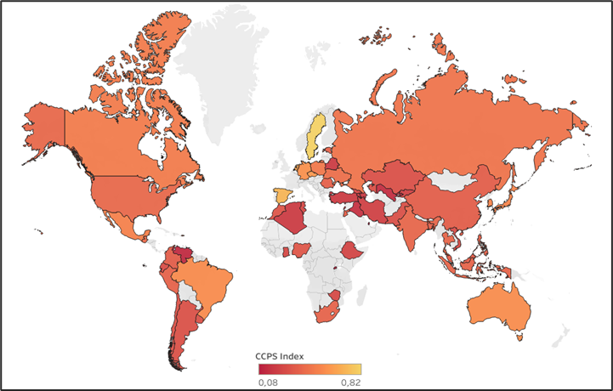

**Figure 1. (1.5 column fitting image).** Spatial distribution of the Climate Change Policy Stringency (CCPS) index (including the 57 countries used for the estimates in this study).Source: Data taken from the CCPS index built by Sharma et al. (2021).

While there is information on the CCPS index for 183 countries, the data available in our study enable us to include 57 countries. The number of countries included is limited to those countries assessed in the Sharma’s CCPS index that, in addition, were taken into account by the WVS to measure the elements that interest us for the computation of the religious tolerance index. Figure 1 shows the spatial distribution of the CCPS index in our sample, where Sweden is the country with the highest index of rigour in the implementation of climate change policies (CCPS = 0.82), while Qatar is the country with the lowest index (CCPS = 0.08).

1. **Religious tolerance**

The measurement of religious tolerance has been built from the data provided by the WVS, which measures the social, political, economic, religious and cultural aspects of people around the world. The information is collected in waves[1] of which there are seven available, with data covering from 1981 to 2022. For the construction of the religious tolerance index, we have referred to the elements in the WVS, according to the criteria proposed by Nussbaum (2012) in her interpretation of the Socratic requirement of an examined life to deal with religious intolerance, which we describe here in a superficial way:

**Table 1** Components of religious tolerance index.

|  |  |  |
| --- | --- | --- |
| **Component** | **Variable** | **Information contained** |
| 1 | Acceptable religions  (relig_acceptable) | In response to the following statement: "The only acceptable religion is my religion," the percentage of people who said they "disagreed" and "strongly disagreed" was included in the measurement. |
| 2 | Religion and science  (relig_and_science) | In response to the following statement: "Whenever science and religion conflict, religion is always right," the percentage of people who said they "disagreed" and "strongly disagreed" was included in the measurement. |
| 3 | Meaning of religion: do good to others  (meaning_do_good) | Faced with the option of choosing the meaning of religion between: "follow religious norms and ceremonies", "do good to others" or "both", the percentage of people who answered "do good to others" and "both" was used. |
| 4 | Meaning of religion  (meaning this world) | Faced with the option of choosing the meaning of religion between: "to give meaning to life after death", "to give meaning to life in this world" or "both", the percentage of people who answered "giving meaning to life in this world" and "both" was used. |

(1) the ability to engage in respectful conversations across the broad terrain of diverse human beliefs and convictions.

(2) an active freedom of conscience that makes it possible to assume one's own beliefs and at the same time develop critical thinking capable of detecting and criticizing one's own inconsistencies, rather than pointing out those of others.

(3) the encouragement of an imaginative view capable of perceiving the world from the points of view of those who have beliefs different from their own.

Thus, with these conceptual elements, we have evaluated the information available in the WVS and selected those questions that allow us to construct a measurement of religious tolerance, taking into account those who (i) do not consider their religion to be the only one which is acceptable, (ii) those who cast doubt on the idea that religion is always correct when conflicts arise with science, (iii) those who claim that the meaning of religion is not only to follow rules and ceremonies but also to do good, and, finally, (iv) those who believe that the meaning of religion is also materialized in this world, and not only in life after death. In general terms, the religious tolerance index is computed as the simple average of the variables expressed in the Table 1. Nevertheless, a robustness test was performed by using an index computed as a weighted average of the relevant components.

**Figure 2. (1.5 column fitting image).** Bivariate scatter plots, histograms, and Pearson correlation for the four components of religious tolerance index. The red line represents the locally estimated scatterplot smoothing fit. (Levels of significance: *[p-value < 0.05], **[p-value<0.01], ***[p-value < 0.001])-

In these elements we can see recognition of the difference implied by religious tolerance and the ability to accept beliefs that are different from one's own; likewise, there is evidence of an ability on our part to discover other religious criteria and convictions, respecting their freedom of conscience, with a critical sense of their own convictions, which are implied in a current and effective respect for life, as pointed out by Nussbaum (2012).

Note that, by using data from all available waves of the WVS for each country in the study, Figure 2 shows that the four components of the religious tolerance index are highly and significantly correlated (ranging from 0.59 to 0.79). The third component (i.e. the percentage of people who consider that the meaning of religion consists fully or partially of doing good) and the fourth component of the index have similar left-skewed distributions and show the highest degree of correlation. In addition to the pair-wise correlation of index components, a Principal Component Analysis (PCA) was performed to verify to what extent the four components of the index represent a common dimension. Thus, we found that the first principal component accounts for about 77% of the total variation (Figure 3). **This internal consistency analysis of the religious tolerance index was strengthened by computing Cronbach’s alpha, which was found to be 0.88.**

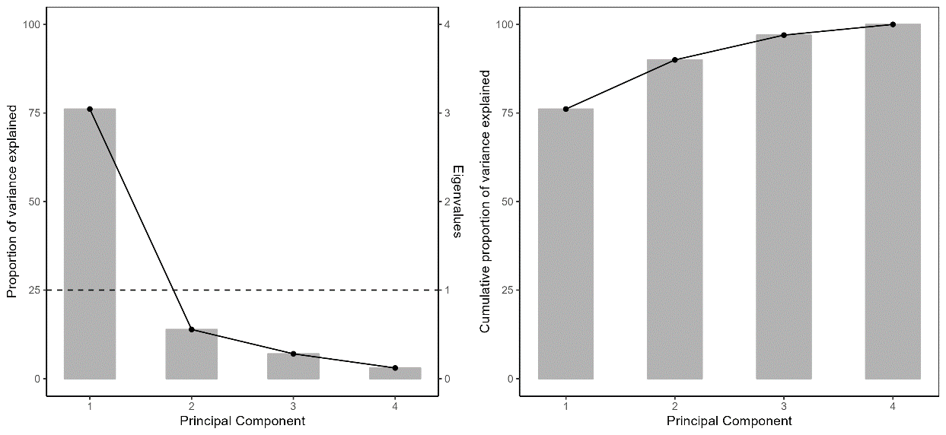

**Figure 3. (2 column fitting image). Left:** Screeplot of principal component analysis of religious tolerance index variables (left). Primary y-axis and secondary y-axis represent the proportion of variance explained (%) and the eigenvalue for each principal component, respectively.The dotted line represents eigenvalue equal to 1. Only theFirst component has eigenvalue > 1. **Right:** cumulative proportion of variance explained (%) by each principal component.

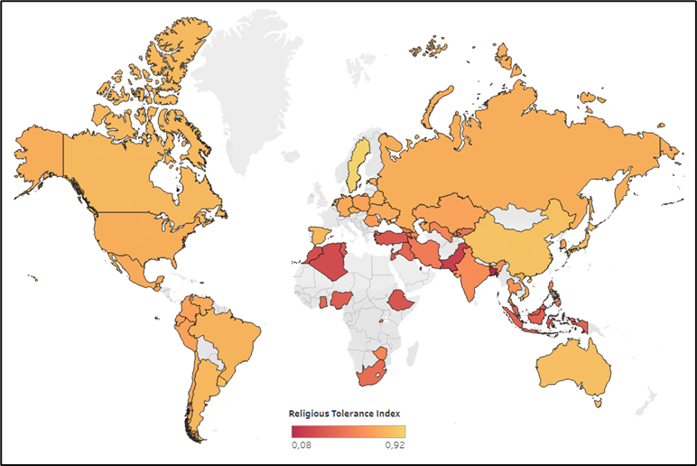

**Figure 4. (1.5 column fitting image).** Spatial distribution of the Religious Tolerance index (including the 57 countries used for our estimates). Source: own calculations based on data from the World Value Survey.

1. **Control variables**

We propose a set of control variables in order to demonstrate the differential effects of the Religious Tolerance Index while retaining the other equivalent information. The control variables correspond to measurements that provide averaged data between the years 2010 and 2014, a time period that coincides with the sixth wave of information from the WVS. We took into account economic, political, institutional and public perception parameters of climate change policies.

**Table 2.** Descriptive statistics on the cross-country Climate Change Policy Stringency (CCPS) index, religious tolerance index, and control variables for countries included in the analysis.

|  |  |  |  |  |  |
| --- | --- | --- | --- | --- | --- |
| Variable | Obs | Mean | Std. Dev. | Min | Max |
| CCPS | 57 | .35 | .15 | .08 | .82 |
| Religious tolerance index | 57 | .59 | .20 | .08 | .92 |
| Acceptable religions | 57 | .52 | .28 | .021 | .94 |
| Religion and science | 57 | .50 | .29 | .015 | .95 |
| Meaning of religion: do good | 57 | .67 | .17 | .16 | .94 |
| Meaning of religion: this world | 57 | .67 | .19 | .08 | .91 |
| Real GDP per capita | 57 | 19907.66 | 20471.78 | 1243.49 | 124657.95 |
| Globalization | 57 | 67.75 | 11.72 | 41.82 | 89.75 |
| Coal production per capita | 57 | .001 | .003 | 0 | .02 |
| Democracy | 57 | 4.22 | 6.10 | -10 | 10 |
| Institutions | 57 | -.16 | .93 | -1.82 | 1.70 |
| Perception of climate change | 57 | .50 | .17 | .18 | .8 |
|  | | | | | |

In the first instance, since a country's income is related to its environmental demand and capacity to design and implement policies, the real GDP per capita Purchasing Power Parity (at constant 2011 international prices) World Bank (2019) was included. Secondly, general globalization index by Gygli et al. (2019) is used to measure openness in the economic (trade and economic globalization), social, and political dimensions. Thirdly, based on data extracted from BP (2020), Enerdata (2019) and EIA (2020), national coal production is taken into consideration, following Sherwood (2011) who points out a negative relationship between the acceptance of climate change and coal production, given its harmful effects on the environment. In fourth place, a democracy index was taken form the Polity IV dataset (Marshall et al., 2017). Fifth, the quality of institutions was considered by means of political stability average and corruption control from Kaufmann & Kraay (2018). Sixth, public perceptions of climate change were controlled using a global survey of views on climate change conducted during 2007-2008 by Gallup (2019)

Finally, regional dummies by continent were incorporated. In accordance with the World Bank classification, the countries in sample are classified into the following regions: East Asia and the Pacific, Europe and Central Asia, Latin America and the Caribbean, the Middle East and North Africa, North America, South Asia, and Sub-Saharan Africa. Table 2 reports the descriptive statistics, including the religious tolerance index and the selected variables of which it consists.

* 1. **Econometric model**

The research of Sharma et al. (2021) will be taken as a reference, these authors having used the data provided by WVS to build a religiosity index supported by the proposal of Bénabou et al. (2015). From this point, and based on the information provided by WVS, we will construct a Religious Tolerance index to contrast its results in relation to the CPSS index above defined. Thus, we propose the following regression model:

${CCPS}_{i}={α+β RT}_{i}+{Γ^{'}CV}_{i}+ϵ_{i}$ (1)

where ${CCPS}_{i}$ is the rigorosity index of climate change policy in country, and ${CV}_{i}$ is an n-vector of control variables that include real GDP per capita, globalization index, quality of institutions, public perceptions of climate change, and regional dummy variables. The error term $ϵ_{i}$ is assumed to be normally distributed with zero mean and constant variance such that $ϵ_{i} \sim N(0, σ^{2})$. The parameter $β$ will be the measurement of the impact of religious tolerance on the rigorosity index of the climate change policy. The null hypothesis to be directly tested is that the relationship between ${CCPS}_{i}$ and religious tolerance is statistically insignificant.

From the regression model expressed in (1), we performed multiple robustness test. The model was estimated by considering the religious tolerance index computed through data from different waves of the WVS (wave VI, wave VII, and all waves excluding wave VII). For the same purpose, we estimate the model considering a religious tolerance index computed as a weighted average of its components, instead of a simple average. Finally, regional dummy variables were used to assess whether the impact of religious tolerance on CCPS index varies by World Bank’s regions.

1. **Results and discussion**

Table 3 shows the results of the regression of the general model we have proposed, always taking into consideration the dummy variables by region. Column (1) contains the information on the regression of ordinary minimum square estimators without taking into account the control variables, which are included in column (2). The results present a positive and statistically significant relationship between religious tolerance and rigour in the implementation of climate change policies in the two models presented. Thus, the reported estimates support the hypothesis presented in this research, as the choice of religious tolerance is associated with an increase of 0.33 points in the rigorosity index of policy implementation against climate change. In the same way, we found statistically significant values with a positive sign for the variables that measure globalization and democracy in countries, which are elements fully related to a tolerant attitude.

It is important to note that some questions were not asked in certain countries of the sample, therefore, the missing values were assigned using a multiple imputation method using non-Bayesian linear regression. However, this method does not offer significant variations, as the missing data represent only 1.27% of the total sample, therefore we have included the non-imputed data in the model, omitting the countries with the missing information. Figure A1, located in the Appendix, shows the irrelevant variation we have found.

Similarly, using the White test (p=0.4271) and the Breusch-Pagan test (p=0.257) we have verified that there is no heteroscedasticity in the model. For this reason, the model has been calculated without correcting robust standard errors.

**Table 3** Influence of religious tolerance index on the implementation of climate change policies.

|  |  |  |
| --- | --- | --- |
| Dependent variable = CCPS | (1) | (2) |
| Religious tolerance index | 0.44 (3.32) *** | 0.33 (3.05) *** |
| Real GDP per capita (log) |  | -0.005 (-0.21) |
| Globalization |  | 0.006 (2.43) *** |
| Coal production per capita |  | 2.04 (0.4) |
| Democracy |  | 0.007 (2.26) ** |
| Institutions |  | -0.02 (-0.71) |
| Perception of climate change |  | 0.08 (0.76) |
| Regions (dummy) |  |  |
| Europe and Central Asia | .001 (0.01) | .082 (1.03) |
| Latin America and Caribbean | -.07 (-0.74) | .025 (0.3) |
| Middle East and North Africa | -.03 (-0.23) | .13 (1.31) |
| South Asia | .12 (0.89) | .25 (2.18) ** |
| Subsaharan Africa | -.04 (-0.33) | .15 (1.46) |
| East Asia and Pacific | .02 (0.19) | .11 (1.29) |
| $$R^{2}$$ | 0.35 | 0.67 |
| Nº of observations | 57 | 57 |

T-statistics are reported in parentheses. ** and *** indicate significance at 5% and 1% levels, respectively. The dummy variable reference by region is North America.

These results contradict the conclusions drawn by Sharma et al. (2021) in which a negative effect of religion on the implementation of climate change policies was generalized; Although focused on one particular element, our measurements are found in the area of religion. It is clear that we have measured different elements, and although contradictory, the conclusions of Sharma et al. (2021) coincide with our own in demonstrating that there are dimensions of religion that are obstacles to the implementation of climate change policies. While we have shown that religious tolerance favours the implementation of such policies, we maintain that religious intolerance and fundamentalism, as confirmed by Preston & Shin (2022) and Skalski-Bednarz et al. (2023), are factors that can hinder pro-environmentalist positions.

To examine the reliability of the results obtained from the general model, four tests were carried out with alternative samples for the measurement of religious tolerance. First, we separately measured the impact of each of the components of the religious tolerance index; secondly, we assessed the results, taking into account data from different waves; thirdly, we included a weighting of the components of the index according to their theoretical importance, before finally estimating the results considering the impact by region.

1. **Impact of index components**

We have carried out individual regressions with each of the variables that make up the religious tolerance index. In the same way in which we have proceeded with the index, each of the variables of which it is made up, also reports the aggregate information of all the waves available in the WVS. Table 4 shows the results of the estimators for each variable, the results of which are similar in the sign, beta magnitude and statistical significance to those found in the estimates carried out with the general model.

**Table 4** Influence of each component of the religious tolerance index on the implementation of climate change policies.

|  |  |  |  |  |
| --- | --- | --- | --- | --- |
| Dependent variable =  CCPS | (1) | (2) | (3) | (4) |
| Religion and science | 0.26(3.01) *** |  |  |  |
| Meaning of religion: do good |  | 0.24 (2.06) ** |  |  |
| Meaning of religion: this world |  |  | 0.19 (1.78) * |  |
| Acceptable religions |  |  |  | 0.23 (2.90) *** |
| Real GDP per capita (log) | -0.01 (-0.39) | 0.001 (-0.05) | 0.003 (0.11) | -0.012 (-0.43) |
| Globalizacion | 0.007 (2.53) *** | 0.007 (2.36) ** | 0.007(2.33) ** | 0.006 (2.24) ** |
| Coal production per capita | 2.68 (0.53) | 3.03 (0.57) | 2.89 (0.54) | 2.63 (0.52) |
| Democracy | 0.008 (2.56) *** | 0.006 (1.88) * | 0.006(1.96) ** | 0.007 (2.26) ** |
| Institution | -0.02 (-0.96) | -0.003 (-0.12) | -0.01 (-0.34) | -.02 (-0.7) |
| Perception of climate change | 0.06 (0.61) | 0.12 (0.99) | 0.08 (0.71) | 0.048 (0.44) |
| Regions (dummy) | Sí | Sí | Sí | Sí |
| $R^{2}$ | 0.67 | 0.63 | 0.62 | 0.66 |
| Nº of observations | 57 | 57 | 57 | 57 |

t-statistics are reported in parentheses. *, ** and *** indicate significance at the 10%, 5% and 1% levels, respectively.

## **Religious Tolerance Index with information of different waves**

To contrast the impact of including the information offered by wave seven while the CCPS index and control variables remained in line with wave 6, as proposed by Sharma et al. (2021), we have tested the robustness of the model by constructing the religious tolerance index by taking all the available information up to wave 6. The results are found in column (1) of Table 5. Likewise, we have inquired about the estimators of a tolerance index that only took into account the information available independently in waves six and seven. The results can be found in columns (2) for wave six and (3) for wave seven of Table 5. As is clear, the results of these regressions are also consistent with the estimates carried out in the general model.

**Table 5** Sensitivity of results according to available information in different waves of World Values Survey

|  |  |  |  |
| --- | --- | --- | --- |
| Dependent variable = CCPS | (1) | (2) | (3) |
| Religious Tolerance Index: excluding Wave 7 | 0.41 (3.42) *** |  |  |
| Religious Tolerance Index: Wave 6 only |  | 0.35 (2.70) *** |  |
| Religious Tolerance Index: Wave 7 only |  |  | 0.29 (1.99) ** |
| Real GDP per capita (log) | 0.017 (0.59) | 0.007 (0.19) | -0.014 (-0.43) |
| Globalization | 0.007 (2.50) *** | 0.008 (1.93) * | 0.005 (1.70) * |
| Coal production per capita | 0.22 (0.04) | 3.59 (0.63) | 3.80 (0.72) |
| Democracy | 0.007 (2.06) ** | 0.006 (1.16) | 0.006 (1.63) * |
| Institutions | -0.03 (-1.16) | -0.03 (-0.95) | 0.010 (0.28) |
| Perception of climate change | 0.03 (0.25) | 0.08 (0.48) | -0.081 (-0.62) |
| Regions (dummy) | Sí | Sí | Sí |
| $$R^{2}$$ | 0.70 | 0.67 | 0.60 |
| Nº de observations | 49 | 44 | 41 |

t-statistics are reported in parentheses. *, ** and *** indicate significance at 10%, 5% and 1% levels, respectively.

1. **Weighted Index**

Next, it has been suggested that the variables chosen to build the index of religious tolerance can contribute differentially to the index, and not as a simple average. In response to Nussbaum's proposal (2012), we believe that questions regarding the consideration of other religions as acceptable, and the criterion of a critical perspective in the apparent conflict between science and religion, can contribute to a greater extent to the structuring of an index of religious tolerance. On the other hand, questions on the meaning of religion linked to life in this world, and the inclination to do good have been treated as signs of tolerance to a lesser degree than the first two questions. Thus, a weighted index of religious tolerance has been constructed with the weighting shown in Table 6.

**Table 6.** Weighting of the components included in the weighted index of religious tolerance.

|  |  |
| --- | --- |
| Variable | Weighting |
| Religion and science | 0.3 |
| Meaning of religion: do good | 0.2 |
| Meaning of religión: this world | 0.2 |
| Acceptable Religions | 0.3 |

For this model we have also performed heteroscedasticity tests, finding results in the Breusch-Pagan test (p=0.7901) and White test (p=0.4265) that allow us to trust the homoscedastic of the model. Thus, the estimates found in Table 7 have been obtained without correcting for robust standard errors. In line with the other robustness tests, the results obtained support the estimates of the main model and assist in corroborating the hypothesis we have wished to defend.

**Table 7.** Influence of the Weighted Index of Religious Tolerance on the Implementation of Climate Change Policies.

|  |  |  |
| --- | --- | --- |
| Dependent variable = CCPS | (1) | (2) |
| Weighted Religious Tolerance Index | 0.35 (2.62) *** | 0.29 (2.11) ** |
| Real GDP per capita (log) |  | -0.014 (-0.46) |
| Globalization |  | 0.005 (1.66) * |
| Coal production per capita |  | 3.10 (0.59) |
| Democracy |  | 0.007 (1.76) * |
| Institucions |  | 0.013 (0.36) |
| Perception of climate change |  | -0.96 (-0.74) |
| Regions (dummy) | Sí | Sí |
| $$R^{2}$$ | 0.34 | 0.60 |
| Nº of observations | 57 | 57 |

t-statistics are reported in parentheses. *, ** and *** indicate significance at 10%, 5% and 1% levels, respectively.

## 

## **Impact by regions**

Finally, an attempt has been made to assess the impact of the regions on the behaviour of the religious tolerance index compared to the CCPS index. Table 8 shows the results obtained for a model with which we have used dummy variables by region to measure the influence of each region on the performance of religious tolerance against the CCPS. We show that the results are only significant for the region of Europe and Central Asia, where there is a positive increase in the impact of the religious tolerance index on the CCPS index, compared with the effect of East Asia and the Pacific, where it is taken as a reference variable. In the other regions, we found non-significant results with evidence of a negative relationship, with the exception of North America with the effect of the Religious Tolerance Index against the CCPS Index. The results of the latter regions are inconclusive as there are insufficient countries per region to create a meaningful model.

**Table 8.** Sensitivity of results according to the region

|  |  |
| --- | --- |
| Dependent variable = CCPS | (1) |
| Religious tolerance index | 0.25 (1.34) * |
| Regions (Effect of interaction with religious tolerance in CCPS) |  |
| Europe and Central Asia | 0.64 (2.59) *** |
| Larin America and the Caribbean | -0.43 (-0.6) |
| Middle East and North Africa | -0.32 (-0.86) |
| North America | 1.21 (0.45) |
| Southern Asia | -0.27 (-0.92) |
| Subsaharan Africa | -0.45 (-1.18) |
| Regions (dummy) | Sí |
| Control Variables | Sí |
| $$R^{2}$$ | 0.78 |
| Nº of observations | 57 |

T-statistics are reported in parentheses. *, ** and *** indicate significance at 10%, 5% and 1% levels, respectively. The variable by region under reference is East Asia and the Pacific

1. **Conclusions**

Religion is a broad, diverse, and complex cultural institution in which a great deal of internal logic is present. Hence, those who seek to explore its characteristics in search of clarity on its impact on any dimension of human life must resist the temptation of superficial approaches that may arbitrarily simplify its internal complexity.

Given the great influence that religions have on human behaviour and the urgency of the climate crisis we are facing, this research is relevant as it provides a more complete understanding of the role that religion can play in the processes of addressing climate change as well as offering tools that contribute to the implementation of the Sustainable Development Goals seven and thirteen proposed by the United Nations (2018). We have shown, contrary to the claims of Sharma et al. (2021), that there are aspects of religion (religious tolerance in this case) that can contribute to a more rigorous implementation of policies to deal with climate change. We have hypothesized that the higher a country's level of religious tolerance, the greater its ability will be to adopt stricter climate change policies.

In the same vein, we could maintain that fundamentalist and intolerant behaviours would be a barrier to the implementation of such policies. Thus, politicians and international organizations can channel their efforts towards strengthening interreligious dialogue as a way of achieving more favourable coexistence among nations and offering a more efficient approach to programs to address climate change.

In this way, we contribute to literature by showing the need to examine more rigorously and deeply cultural phenomena such as religion, and their internal logic, while the complexity of their internal networks allows us to demonstrate dissimilar impacts depending on the angle from which these phenomena are studied. This research is limited to a specific logic, but opens the door to other approaches that explore particular religions and their internal structures to assess the way in which they relate to strategies to confront the climate crisis.

1. **References**

Bénabou, R., Ticchi, D., Vindigni, A. (2015). Religion and innovation. Am. Econ. Rev. 105, 346–351.

Bernauer, T., Böhmelt, T. (2013). National Climate Policies in international comparison: the climate change cooperation index. Environ. Sci. Pol. 25, 196–206.

Botta, E., Kozluk, T. (2014). Measuring Environmental Policy Stringency in OECD Countries.

BP (2020). Statistical Review of World Energy, 2019. Accessed in: June 2020. Available at: <https://www.bp.com/en/global/corporate/energy-economics/statistical-review-of-world-energy.html>

Broer, N. A., Muynck de, B., Potgieter, F. J., Wolhuter, C. C., & Walt van der, J. L. (2014). Measuring religious tolerance among final year education students: The birth of a questionnaire. International Journal for Religious Freedom, 7(1/2), 77–96.

Chaudoin, S., Smith, D.T., Urpelainen, J. (2014). American evangelicals and domestic versus international climate policy. Rev. Int. Organ. 9, 441–469.

DiMaggio, P. J. & Powell, W.W. (1983). The iron cage revisited: institutional isomorphism and collective rationality in organizational fields." American Sociological Review, 48(2): pp.147-160.

EIA (2020). U.S. Energy Information Administration. Accessed at: [https://www.eia.gov/coal/data.php](https://www.eia.gov/coal/data.php%20%20%20)

Ecklund, E., Scheitle, C., Peifer, J. & Bolger, D. (2017). Examining Links Between Religion, Evolution Views, and Climate Change Skepticism. Environment and Behavior, Vol. 49(9) 985–1006. <http://doi.org//10.1177/0013916516674246>

Enerdata (2019). Global Energy Statistical Yearbook 2019. Accessed in: June 2020. Available at: <https://yearbook.enerdata.net/coal-lignite/coal-production-data.html>.

Gallup (2019). Global Opinions about Climate Change, 2007–08.

Gygli, S., Haelg, F., Potrafke, N., Sturm, J.-E. (2019). The KOF globalization index revisited. Rev. Int. Organ. 1–32.

Hoffman, A. (2011). Talking Past Each Other? Cultural Framing of Skeptical and Convinced Logics in the Climate Change Debate. Ross School of Business. University of Michigan. Working Paper No. 1154

Hook, J. N., Farrell, J. E., Johnson, K. A., Van Tongeren, D. R., Davis, D. E., & Aten, J. D. (2017). Intellectual humility and religious tolerance. The Journal of Positive Psychology, 12(1), 29-35.

Haerpfer, C., Inglehart, R., Moreno, A., Welzel, C., Kizilova, K., Diez-Medrano J., M. Lagos, P. Norris, E. Ponarin & B. Puranen (eds.). 2022. World Values Survey: Round Seven - Country-Pooled Datafile Version 5.0. Madrid, Spain & Vienna, Austria: JD Systems Institute & WVSA Secretariat. <http://doi.org//10.14281/18241.20>

Hulme, M. (2015). Varieties of religious engagement with climate change. In: Willis, J., Tucker, M.E., Grim, J. (Eds.), Routledge Handbook of Religion and Ecology. Routledge International Handbooks, Routledge, Abingdon, p. 239.

IPCC, 2022: Climate Change 2022: Mitigation of Climate Change. Contribution of Working Group III to the Sixth Assessment Report of the Intergovernmental Panel on Climate Change [P.R. Shukla, J. Skea, et al. (eds.)]. Cambridge University Press, Cambridge, UK and New York, NY, USA. doi:10.1017/9781009157926.

Johansson, A., Berggren, N. & Nilson, T. (2022). Intolerance predicts climate skepticism. Energy Economics 105 (2022) 105719. <https://doi.org/10.1016/j.eneco.2021.105719>

Junaedi, M., Nasikhin, Hasanah, S., & Hassan, Z. (2023). Learning patterns in influencing attitudes of religious tolerance in Indonesian universities. Education Sciences, 13(3), 285. <https://doi.org/10.3390/educsci13030285>

Kaufmann, D., Kraay, A. (2018). <http://info.worldbank.org/governance/wgi/index.aspx#home>.

Lieven, A. (2012). America Right or Wrong: An Anatomy of American Nationalism. Oxford University Press, USA.

Marshall, M.G., Gurr, T.R., Jaggers, K. (2017). Polity IV Project: Political Regime Characteristics and Transitions, 1800–2017 (Dataset Users’ Manual).

Mehak, B., & Bushra, A. (2020). Development and validation of religious tolerance scale for youth. Journal of Religion and Health, 59(3), 1481-1493. <https://doi.org/10.1007/s10943-019-00897-5>

Meyer, J.W. & Rowan, B. (1977). "Institutionalized organizations: formal structure as myth and ceremony." American Journal of Sociology, 83(2): pp.340-363

Molina, M., Pérez-Garrido, M. (2022). LAUDATO SI’ and its influence on sustainable development five years later: A first LOOK at the academic productivity associated to this encyclical. Environmental Development (43) <https://doi.org/10.1016/j.envdev.2022.100726>.

Muhammad L. H., Indah D. Q. & Abdul W. (2023). A paradox between religious conviction and recognizing the freedom of others on measuring religious (in) tolerance index in East Java, Indonesia, Cogent Social Sciences, 9:1, DOI: 10.1080/23311886.2023.2191443

Nussbaum, M. (2012). The new religious intolerance: Overcoming the politics of fear an anxious age. Harvard University Press.

Preston, J. L., & Shin, F. (2022). Opposing effects of spirituality and religious fundamentalism on environmental attitudes. Journal of Environmental Psychology, 80, 101772.

Skalski-Bednarz, S.B., Konaszewski, K., Toussaint, L.L. et al. (2023). Relationships between religion, moral foundations, and environmentalism in young adult Catholics. j. relig. educ. 71, 91–107 https://doi.org/10.1007/s40839-023-00198-w

Sharma, S., Ang, J., Fredriksson, P.G. (2021). Religiosity and climate change policies. Energy Econ. 101. <https://doi.org/10.1016/j.eneco.2021.105414> .

Sherwood, S. (2011). Science controversies past and present. Phys. Today 64, 39–44.

Singh, P., Singh, N. (2019). Political economy of bioenergy transitions in developing countries: A case study of Punjab, India. World Development. (124) <https://doi.org/10.1016/j.worlddev.2019.104630>

Steves, F. & Teytelboym, A. (2013). Political Economy of Climate Change Policy. SSEE. Working Paper 13-02 Available at SSRN: <https://ssrn.com/abstract=2456538>.

United Nations (2015). Transforming our world: the 2030 Agenda for Sustainable Development. <https://wedocs.unep.org/20.500.11822/9814>.

Weber, M. (1930). The Protestant Ethic and the ‘‘Spirit’’ of Capitalism and Other. Writings. Allen & Unwin. New York: Roxbury Publishing Company.

Wilkins, D. (2022). Catholic clerical responses to climate change and Pope Francis’s Laudato Si’. Nature and Space. Vol. 5(1) 146–168 <http://doi.org//10.1177/2514848620974029>

World Bank (2019). The World Development Indicators. Accessed in: April 2019. Available at: <https://data.worldbank.org/>.

1. **Appendix**

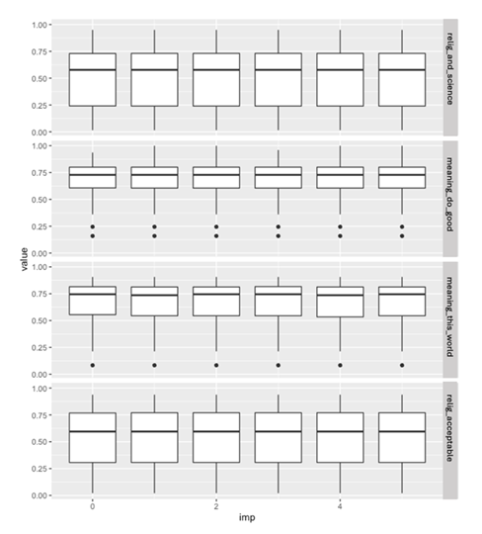

**Figure A1. (1.5 column fitting image).** Distributions for the four components of religious tolerance index obtained from the original data (imp = 0) vs. distributions obtained from multiple imputation procedure (five imputed data sets depicted in the last five boxplots for each row in the figure). Analysis showed no significant difference between non-imputed and imputed data.

1. Waves are periods of time in which respondents' responses are collected; thus, the information collected constitutes a cross-sectional dataset for the time period of the wave.